Central Goldfields

Drugs and Liquor Accord

2022-2025

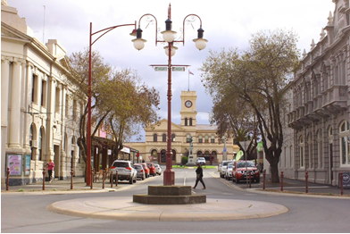







Date: April 2022

Version: No 3

**CONTENTS:**

1. Aim 3
2. Introduction 3
3. Priorities/Objectives 4
4. Best Practice Principles 5

5.1 Responsible Service of Alcohol 5

5.1.2 Minors 6

5.1.3 Checking ID 6

5.1.4 Discouraging activities 7

5.1.5 Promoting activities 8

5.1.6 Training 9

5.2 Responsible Service of Alcohol Self Audit Checklist 10

6. Crowd Controllers 11

7. Improved Safety and Security 11

7.1 Self-Audit Checklist 12

7.2 Records Management 13

7.3 Patron Safety 13

7.4 Safety Checklist 14

8. Commitment to Being Good Neighbours 15

8.1 Self-Audit Checklist 15

9. Accord Banning Guidelines 16

9.1 Release of information 17

10. Acknowledgement of Commitment 17

11. Alcohol prohibited map 18

12. Victoria Police 19

1. **AIM**

*‘To improve public safety, amenity and perceptions of safety by reducing alcohol related crime and harm in the Central Goldfields Local Government Area’*

1. **INTRODUCTION**

The Accord is a partnership between key interest groups in the Central Goldfields Shire sharing the common goal of achieving safe and well-managed environments at licensed venues. The Accord aims to:

* Encourage the implementation of best practices in the management of licensed premises
* Promote responsible standards of behaviour by patrons and protect their safety; and,
* Maintain high standards of behaviour in and around licensed premises.

Membership to the Accord is voluntary and open to all licensed premises including licensees of restaurants, clubs, packaged liquor outlets, pubs and hotels and licensed sporting clubs. Members of the Accord can include Victoria Police, Central Goldfields Shire Council, licensees and other interest groups.

Whilst membership is voluntary, the issues and activities addressed by the Accord are serious and include community safety, licensing and permit issues, patron behaviour and control, and venue management. The Accord aims to address these topics in a supportive and cooperative environment.

The Accord strives for continuous improvement of licensed venues through encouraging the adoption of best practices in venue management. This is achieved through providing members with access to information and training, open channels of communication and support from Victoria Police (VICPOL), Central Goldfields Shire Council (CGSC) and Victorian Gambling and Casino Control Commission (VGCCC) and the opportunity to learn from other licensees and establish a common voice in relation to issues affecting licensees.

When operating effectively, the Accord can positively influence community safety through minimising harm from alcohol misuse and facilitate a vibrant, successful and responsible hospitality industry. Further, members can also gain positive community recognition for their commitment. The Accord is characterised by members who take pride in and work harmoniously with their local community.

In order to be successful, the Accord requires active participation by members, support from licensees, a co-operative approach and commitment from members to proactively address issues and jointly solve problems.

1. **PRIORITY AREAS, OBJECTIVES AND STRATEGIES**

|  |  |
| --- | --- |
| Priority Area: | Addressing contributors to alcohol related crime and harm |
| Objective: | To reduce factors that contribute to alcohol related crime and violence in and around licensed venues |
| Strategies: | * Adhere to Responsible Service of Alcohol (RSA); * Eliminate practices that lead to the misuse of alcohol; * Eliminate illegal underage patronage at all licensed premises; * Eliminate false identification used by underage persons; * Eliminate promotions and practices that encourage the irresponsible service and consumption of alcohol; and |

|  |  |
| --- | --- |
| Priority Area: | Creating a safe environment in and around licensed premises. |
| Objective: | To improve safety and perceptions of safety in and around licensed venues |
| Strategies: | * Maintain a high standard of public amenity * Working collaboratively with responsible body to protect the physical amenity of Central Goldfields Shire; * Adhere to best practice in the management of licensed premises; * Identify and report issues of public safety to the responsible body; * Promote and support the use taxis; and * Promote and support the Public Place CCTV System (City Safe Safety Cameras); and * Actively contribute to the development of projects and programs that improve safety and perceptions of safety around licensed venues. |

|  |  |
| --- | --- |
| Priority Area: | Positively contributing to public health, wellbeing and safety. |
| Objective: | Tocontribute to the health, wellbeing and safety of residents and visitors to Central Goldfields |
| Strategies: | * Encouraging positive health and social behaviours by the community, in relation to the consumption of alcohol; * Promote and encourage the use of “Designated Driver” programs * Support and promote best practice programs which improve the health, wellbeing and safety of residents and visitors to the area |

1. **BEST PRACTICE PRINCIPLES**

This section outlines industry accepted best practice principles for licensees. It is expected that licensees committed to the Central Goldfields Drugs and Liquor Accord adhere to these principles in order to operate a business within a best practice framework.

The Central Goldfields Drugs and Liquor Accord – Best Practice Principles are founded on a harm minimisation approach that aims to minimise and reduce harm to individuals, families and the broader community as a result of alcohol and other drugs misuse.

In applying these principles, it is recognised that some aspects outlined may only apply to a certain types of liquor licence. For example *‘Ensure that the maximum capacity numbers of patrons are adhered to at all times’* would not apply to packaged liquor outlets. However, most of the recommendations contained in this section have been modified to apply to all licence types.

* 1. **Responsible Service of Alcohol**
* Refuse service of alcohol to any patron showing signs of **intoxication;**
* Refuse entry to all intoxicated patrons;
* Encourage patrons to drink responsibly and let them know they will be asked to leave if they become intoxicated, disorderly, violent or quarrelsome; and
* Notify crowd controllers of patrons who are showing signs of intoxication so that crowd controllers can monitor and manage the situation.
* Ensure staff, are adequately trained to identify intoxicated patrons.

<https://www.vcglr.vic.gov.au/sites/default/files/Intoxication_guidelines.pdf.pdf> <https://www.youtube.com/watch?v=GQ1xpd8phF4>

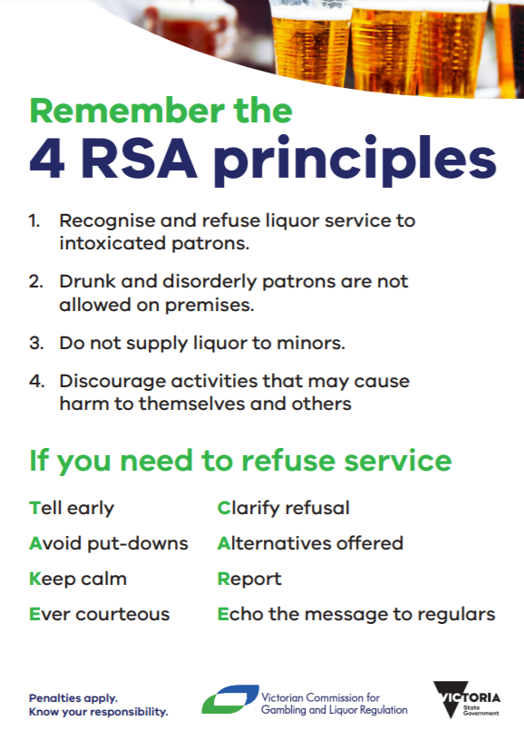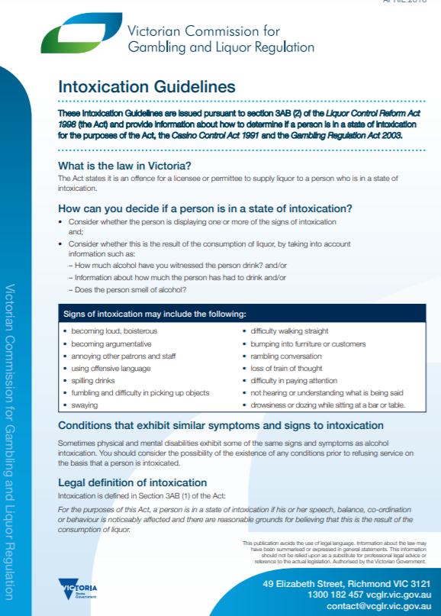

**5.1.2. Minors**

**Minors on licensed premises**

Anyone under the age of 18 years is considered a minor.

The legal drinking age in Victoria is 18 years. **It's illegal for any person to supply alcohol to a minor on licensed premises.** It's also illegal for a minor to be on licensed premises to purchase, receive or consume alcohol.

**Minors are not permitted to drink alcohol on licensed premises under any circumstances.**

Depending on the situation, a minor may be allowed on licensed premises.

A minor may be on licensed premises if they are in the company of a *responsible adult*.

A *responsible adult* is defined as a person who is 18 years or older and is:

* the minor's parent, step-parent, guardian, grandparent, or
* the minor's spouse who is over the age of 18 years, or
* a person who is acting in place of a parent and who could reasonably be expected to exercise responsible supervision of the minor – for example, a sporting coach.

An unaccompanied minor cannot be on licensed premises unless:

* there is a condition allowing them to be on the licence (for example, a junior sports club)
* it holds a restaurant and cafe licence (until 11pm)
* it holds an on-premises licence with restaurant conditions (until 11pm)

Other circumstances that permit minors on licensed premises are if the minor is:

* having a meal, or
* is a resident of the premises if accommodation is supplied, or
* employed by the licensee but not involved in the supply of alcohol, or
* completing a VGCCC approved training program in hospitality - the approval is normally given in writing and under the condition they are closely supervised whilst serving.

**5.1.3. Checking Identification**

One of the key aims of this Code of Practice is to actively discourage illegal underage patronage and with that, illegal underage drinking on or from licensed premises of all kinds. To achieve this:

* Insist on the production of evidence of age documents, as specified by the *Liquor Control Reform Act 1998*, for entry to all licensed venues/point of sale where appropriate;
* Prominently display VGCCC signage about restrictions on minors;
* When checking ID, the ID is removed from a wallet/purse or cardholder and held by the staff member conducting the check to ensure it is current and an approved form of identification
* If an approved form of ID is not supplied, no admittance to the premises is to be permitted unless the patron is obviously over the age of 18 years. Entry will be at the discretion of the venue operator or delegate;
* If an approved form of ID is requested and not supplied at a packaged liquor outlet, no sale will be permitted to take place; unless the patron is obviously over the age of 18 years. Entry will be at the discretion of the venue operator or delegate; and
* If staff believe that a document being presented is false, defaced or in the possession of a person who is not the owner of the ID then the document will be confiscated and handed to the police (excluding a driver’s licence).

Acceptable evidence of age documents under the *Liquor Control Reform Act 1998*are:

* Australian driver licence (including NSW & SA [digital drivers licence](https://www.vcglr.vic.gov.au/news/accepting-digital-identification-id-documents))
* Victorian learner permit
* Foreign driver licence in the English language or if not in the English language, must be accompanied by an official English translation or an International Driving Permit
* [Victorian proof of age card](https://www.vcglr.vic.gov.au/i-want/get-proof-age-card) or an equivalent from another state or territory of Australia
* Keypass card (including [digital keypass](https://www.digitalid.com/personal) )
* Australian or foreign passport
* Victorian marine licence

**5.1.4 Discourage activities that encourage drinking alcohol excessively**

Actively discourage irresponsible alcohol consumption practices such as:

* Free or heavily discounted drinks on entry or during the night at licensed venues;
* Lay backs, two for one drinks, short term price reductions and the indiscriminate distribution of drink cards **(Distribution of free drink cards must be in a direct sponsorship or formally structured promotional plan**);
* All-inclusive events which have the potential for alcohol abuse
* Serving of liquor to persons already adversely affected by alcohol;
* Serving of ‘shooters’ after 12:01AM;
* No pricing practices or promotions that encourage rapid consumption of alcohol or alcohol abuse are conducted;
* No practices or promotions to encourage rapid consumption of alcohol such as Drinking Games, Skolling Competitions, Dares or Challenges and no Pouring Straight Alcohol into patrons mouths;
* No advertising of events that encourage excessive consumption of alcohol eg, being binge drinking, sporting clubs end of season celebrations (Mad Monday), end of school celebrations (schoolies week), start of university celebrations (O-Week);
* Happy Hours will be kept to a maximum of two hours per day, per venue operation and will be completed by 11:00pm on any operating night; and
* Serve drinks at standard measures.
* All licensees (members) of the Central Goldfields Liquor Accord are to become familiar with the VGCCC [“Responsible Liquor Advertising and Promotions” guidelines.](https://www.vcglr.vic.gov.au/sites/default/files/cd_22_1525_attachment_c_-_final_revised_responsible_liquor_advertising_and_promotion_guideline_dlt_converted1_3.pdf)

Amounts for only 1 Standard Drink

The following amounts are a guide for 1 standard drink based on the alcohol content. These are calculated based on the formula supplied by the Department of Health and Ageing ([reference](http://www.alcohol.gov.au/internet/alcohol/publishing.nsf/Content/standard)).

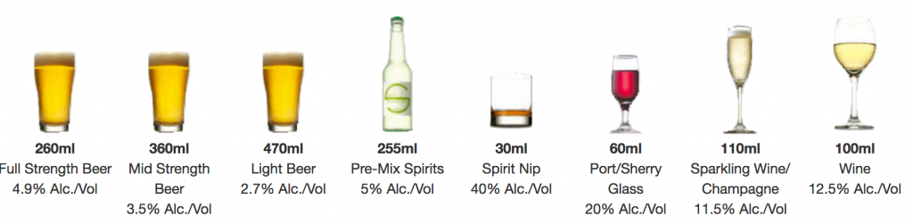

<https://www.vcglr.vic.gov.au/promotions-banned-vcglr>

<https://www.vcglr.vic.gov.au/liquor/restaurant-cafe/understand-your-liquor-licence/responsible-alcohol-advertising-and-promotion>

**5.1.5 Promote non-alcoholic or low alcoholic beverages and snacks**

* At all times, offer and promote the availability of low and non-alcoholic drinks, through signage;
* Ensure bottled water is available for purchase and free tap water is available to all patrons; (This is a legal requirement under section 99A *Liquor Control Reform Act 1998* – <https://www.vcglr.vic.gov.au/free-water-patrons>)
* Ensure refreshments (food) are readily available on the licensed premises for purchase and be in a position to provide such refreshments on request at any time where liquor is available for supply *(*This is a legal requirement under section 99 *Liquor Control Reform Act 1998)*

**5.1.6 Ensure all staff, are adequately trained.**

* + RSA training is mandatory for licensees and staff selling, offering or serving liquor for general, on-premises, late night and packaged liquor licences.
  + Licensees and staff who are subject to mandatory RSA requirements have one month from the date they first sell, offer for sale or serve liquor on a licensed premise to complete an approved RSA training course

<https://www.vcglr.vic.gov.au/resources/education-and-training/responsible-service-alcohol>

<https://liquor.vcglr.vic.gov.au/rsa_refresher/>

* + Once you have completed the initial accredited course SITHFAB002, you must complete a free online refresher course every three year <https://liquor.vcglr.vic.gov.au/rsa_refresher/>
  + A list/register of minors employed on the premises (which may be the business time and wages record book) is maintained by the licensee and is available upon request for viewing by an authorised officer of the Victorian Police or authorised person;
  + Have a copy of every staff members most recent Responsible Service of Alcohol Certificate available on request
  + Provide regular updates to all staff regarding the Accord and related responsible service of alcohol and harm minimisation policies and practices;
  + Ensure strict reference checks are conducted on all staff in the context of good recruitment practices, including security staff;
  + Ensure staff have access to relevant literature on the Accord, liquor laws and regulations and surrounding business owners and residents to achieve this outcome; and
  + Cooperate with Victoria Police, Central Goldfields Shire Council and fellow operators to ensure this code of practice can be effectively implemented across Central Goldfields.

**NOTE:**

**Licensees and staff are to be aware that there are local laws that prohibit the consumption and possession of unsealed liquor in specified public areas within Central Goldfields Shire (refer to map on page 19)**

**5.2 RESPONSIBLE SERVICE OF ALCOHOL SELF AUDIT CHECKLIST**

The attached Self-Audit Checklist is designed to assess the effectiveness of the licensee’s commitment to Responsible Service of Alcohol.

|  |  |  |  |
| --- | --- | --- | --- |
| Requirement | **Yes** | **No** | **Action Required** |
| Licensees have completed and are trained in the Licensees “New Entrant Training” course. |  |  |  |
| Licensees and staff have read and understood their liquor licence. The current liquor licence is prominently displayed. |  |  |  |
| All liquor service staff have completed and are trained in “RSA” within one month of commencing employment or are the holder of an approved Responsible Service of Alcohol Certificate. Complete the RSA Refresher program every three years |  |  |  |
| The current red line plan of the premises is available for inspection by Victoria Police or Compliance Inspectors. |  |  |  |
| Required signage is prominently displayed. |  |  |  |
| Minors employed in the licensed premises are not involved in the sale or supply of alcohol and their employment is registered and available to Police or an authorised officer when requested. |  |  |  |
| Patrons’ identification is actively monitored at the door to ensure they are not underage. |  |  |  |
| Promotions and advertising do not encourage the rapid consumption of alcohol. |  |  |  |
| Low and non-alcoholic drinks are readily available. Water is available free, in line with legislation. |  |  |  |

<https://www.youtube.com/watch?v=SC5q8BfgYqA>

<https://www.youtube.com/watch?v=WXsaE-T6sCg>

**6. CROWD CONTROLLERS**

The State Government has implemented *The Private Agents Act* *2004* and set up the Private Agents Register within the structure of the Victoria Police. Both the Statutory and the Regulatory bodies are required to screen, control and monitor the behaviour and the bona fide's of all persons employed for this purpose. This has extended to requiring all such persons that are employed in the capacity of Crowd Controllers to be licensed and to abide by the operational requirements of the Act. (Licensees should be actively enforcing this in their premises).

*The Private Agent's Act 2004* at Part 1 VA, contains legislation covering the keeping of Crowd Controllers Register, and the identification required to be worn by persons employed for that purpose.

**This code of practice requires all licensees who employ crowd controllers to be thoroughly conversant with their obligations under the *Private Agents Act 2004*, and to ensure that all persons employed in that capacity are properly licensed and work in a professional manner.**

Crowd Controllers must adopt effective conflict resolution and communication skills with the aim of reducing violence on or around licensed premises.

This proposal also stresses the proposition that licensees have a duty of care with respect to their patrons, and that this duty of care should be demonstrated through the professional application of crowd controllers and bar staff to the principles of 'Responsible Service' and the creation of a safe environment*.* It is suggested that venues, which provide entertainment, should employ adequate crowd controllers in order to ensure the provision of that safe environment (Recommended - two crowd controllers for the first 100 patrons and one extra for each additional 100 patrons or as per licence conditions) – ensure adherence to the liquor licence conditions.

Conferences and courses held to update crowd controllers on techniques and best practice should be encouraged by licensees, as well as the necessity to expose crowd controllers to the Responsible Service of Alcohol Training Sessions in order to highlight, better equip and assist the proactive aspects of their duties

**7. IMPROVE SAFETY AND SECURITY**

Actively monitor the behaviour of patrons to detect early signs of intoxication or inappropriate behaviour

* Clearly display a house policy that details acceptable and unacceptable behaviour on premises, including non-acceptance of excessive consumption of alcohol or illicit drug use;
* Signage that educates patrons and explains the harms associated with drug misuse and abuse, including [drink spiking](https://www.vcglr.vic.gov.au/sites/default/files/21_29_prevent_drink_spiking_patrons_1.pdf), drink/drug driving and tobacco smoking, is displayed throughout the premises;
* Discourage glass in toilets or on the dance floor, to reduce both

intentional and accidental injuries;

* Ensure internal and external security procedures are well maintained and functioning effectively;
* Encourage phased and orderly exit of patrons from premises when closing;

**7.1 Maintain safety and security throughout the premises**

* An Emergency Procedures Management Plan is maintained and available to Victoria Police. All staff are trained in emergency procedures and the use of emergency equipment;
* Conduct regular WorkSafe crowd control safety and security risk assessment of premises and immediate surrounds;
* Ensure entrances and exits are well lit and that immediate surrounds are safe and allow good visibility;
* Implement good surveillance systems, such as closed circuit television systems (CCTV), on premises;
* Ensure staff, including security staff, are clearly identifiable (for example, distinctive t-shirts, uniforms, name tags etc);
* Serve alcohol in containers selected to minimise possible harm to patrons. Where possible, glasses are made of shatter proof glass;
* Where possible stock liquor in unbreakable containers, such as cans or plastic bottles, instead of glass bottles;
* Fully cooperate with police and other Accord members on ways to improve public safety;
* Prevent criminal activity and disorderly conduct from occurring on premises. Notify police immediately if something illegal or suspicious does occur;
* When required, agree to implement additional or local strategies that relate to specific safety and security issues in and around the premises. These strategies will be negotiated as part of the Central Goldfields Liquor Accord;
* Door/security or reception personnel will:
* Wear clear ID at all times;
* Not harass or intimidate passers-by or potential customers;
* Record incidents of false ID and fraudulent use of ID into the incident book;
* Monitor and discourage anti-social behaviour when patrons leave the premises, both near and immediately surrounding the premises, and call police if necessary;
* Not let people back into premises who have caused a disturbance – Immediately contact police and other premises to inform them of patrons that have been ejected and/or problem patrons in the vicinity;
* Have public transport information available including taxis, trains, buses and car parking for patrons and location of the nearest public telephone;
* Assist patrons in accessing safe transportation out of the area; and
* Uphold any statutory requirements relating to security personnel and enter details of any incidents in the incident book.

**7.2 Maintain records of incidents and have regular communication with police**

* Maintain a register of all types of incidents that occur in and around the premises that includes the time, date and nature of the incident and the response taken by staff and management
* Ensure all staff are familiar with the incident register book and are aware of how to use it when required;
* Notify the police of any special events likely to significantly increase the number of people in the area, in advance of the event;
* Ensure close liaison and open communication with all Central Goldfeilds Liquor Accord Stakeholders.

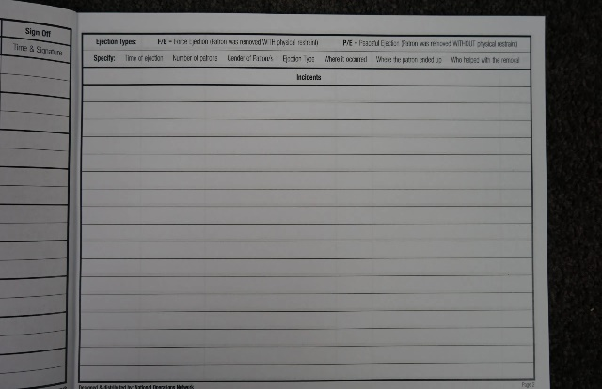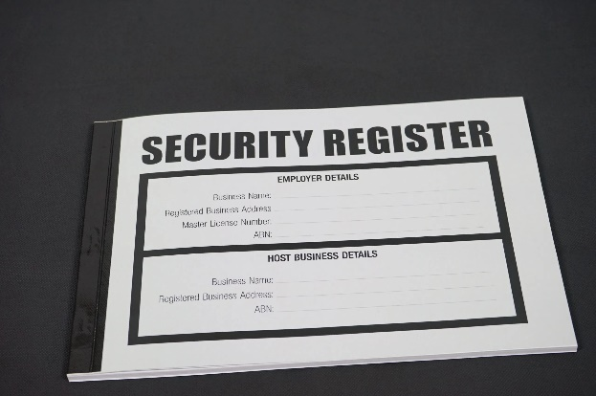

**7.3 Patron and premises safety**

* Maintain a current list of emergency phone numbers and locate close to all key phones;
* Ensure that the maximum capacity numbers of patrons are adhered to at all times;
* Ensure that crowd controllers employed by the premises hold a current Private Security Licence;
* Encourage a policy of no pass-outs after midnight;
* Train all staff to know help procedures and emergency numbers and how to use the incident register book;
* Encourage all staff members to undertake first aid courses and ensure one staff member with a first aid certificate is rostered on for each shift; and
* Ensure the telephone listing, for communication with security at other venues, is routinely updated.

**7.4 SELF-AUDIT CHECKLIST FOR SAFETY AND SECURITY**

Self - Audit Checklist designed to assess the effectiveness of the licensee’s commitment to safety and security.

|  |  |  |  |
| --- | --- | --- | --- |
| Requirement | **Yes** | **No** | **Action Required** |
| All crowd controllers are trained and hold a current Private Security Licence. |  |  |  |
| The crowd controllers register is properly maintained. |  |  |  |
| A house policy has been developed and is displayed for patrons’ information. |  |  |  |
| An Emergency Procedure Management Plan is in place. |  |  |  |
| Staff are informed and trained in emergency procedures. |  |  |  |
| A Patron Management Plan is in place and all staff are trained in implementing the plan. |  |  |  |
| Where applicable, video surveillance cameras are installed and placed in the appropriate locations. |  |  |  |
| Surveillance footage is retained in accordance with licence requirements. |  |  |  |
| Where possible, glasses are shatter glass and preference is given to stock liquor in unbreakable containers. |  |  |  |
| Security and reception staff are aware of the closest taxi and public transport options. |  |  |  |
| An employee is present who holds a current accredited first-aid certificate during operating hours. |  |  |  |
| All relevant staff are aware of maximum numbers permitted on the premises. This includes relevant management and security personnel. |  |  |  |
| Staff will monitor and discourage anti-social behaviour both in and near licensed premises. |  |  |  |
| All staff understand the procedures of recording an incident in the incident book. |  |  |  |

**8. COMMITMENT TO ‘BEING GOOD NEIGHBOURS’**

**Improve the local amenity**

* Assist patrons in accessing safe transportation out of the area. For example, door staff are able to provide information about access to the supervised taxi rank or train station and encourage patrons to use these quickly and quietly when departing;
* Minimise noise generated from the premises, wherever possible, keep doors closed;
* Educate patrons, including through signage, about the need to respect the local amenity and to arrive and depart the area in a quiet and orderly manner;
* Prevent the unlawful removal of liquor (other than packaged liquor where permitted) from licensed premises;
* Ensure door and security staff, are briefed on local environment issues, including potential traffic, noise or security problems;
* Ensure police are informed of regular closing hours and any variations, such as special events or new activities;
* Record all legitimate complaints in the incident book, respond to resident concerns and take all reasonable steps to ensure the premise is functioning as a ‘good neighbour’; and
* Communicate with neighbouring premises to discuss any common issues surrounding the premises.

**Patron responsibility**

* Display signage that clearly explains licensee and patron responsibility regarding the responsible service of alcohol <https://www.vcglr.vic.gov.au/print-my-liquor-signage> ;
* Ensure staff are trained appropriately to advise patrons when they will no longer be served and will be asked to leave the premises;

**8.1 Self-Audit Checklist designed to assess the effectiveness of the licensee**

|  |  |  |  |
| --- | --- | --- | --- |
| Requirement | **Yes** | **No** | **Action Required** |
| Queues are managed so as to be orderly and do not obstruct access to footpaths for other users. |  |  |  |
| The crowd controllers register is properly maintained. Management and security staff will work cooperatively with other venues and authorities to protect the amenity of other people. |  |  |  |
| Staff and management will encourage people to leave the premises in a quiet and orderly manner. |  |  |  |
| All staff are aware of the process of recording complaints in the incident book and know how to respond to them. |  |  |  |

**9. ACCORD BANNING GUIDELINES**

The *Liquor Control Reform Act 1998* provides that two or more licensees or permittees may enter into a liquor accord with the approval of the Chief Commissioner of Police and the Victorian Gaming and Casino Control Commission (**VGCCC**), for the purpose of minimising harm arising from the misuse or abuse of alcohol.

The terms of a liquor accord may make provision for licensees or permittees to cease to supply liquor or allow the consumption of liquor at their licensed premises or ban access to the premises by the public or individual members of the public.

Liquor accord bans should be implemented only for the purpose of minimising harm arising from the misuse and abuse of alcohol in relation to behaviour that has occurred in or around licensed premises. It is recommended that parties to an accord:

* ensure that a decision to ban is fair and reasonable, providing the banned person with an opportunity to respond to or apply for the reconsideration of the decision to ban them;
* ensure that a ban is non-discriminatory and made for a clear harm minimisation purpose;
* ensure that the privacy of personal information in relation to banned persons is maintained;
* ensure that a ban complies with the provisions of the [Charter of Human Rights and Responsibilities Act 2006 (Vic);](https://www.legislation.vic.gov.au/in-force/acts/charter-human-rights-and-responsibilities-act-2006/014)
* do not ban persons for unreasonable periods of time (maximum 12 months) unless clearly justified by the circumstances; and
* appropriately notify the subject of a ban that a decision has been made to exclude them.

From 31 January 2022, the maximum period for which a person may be banned under a liquor accord is 12 months.

A licensee or permittee may consult Victoria Police to assist it with developing or enforcing a liquor accord.

## Release of information for the purpose of enforcing an accord ban

The Commission or a police officer may disclose to a licensee or permittee who is a party to a liquor accord that contains a liquor accord ban information about a person who is the subject of a ban. It is a criminal offence for a person to use or disclose any information received from us or Victoria Police regarding banned persons except for the purposes of enforcing a liquor accord ban or other purposes required by law, with a maximum penalty of 60 penalty units. (Refer to Section 146DA of the *Liquor* *Control Reform Act 1998*)

Information will only be disclosed by the VGCCC in accordance with section 146D of the *Liquor Control Reform* *Act* *1998* wherenecessary for the purposes of the effective and efficient enforcement of the ban. When determining whether to disclose information, the VGCCC may require a party to an accord to undertake not keep the information private.

**10. ACKNOWLEDGEMENT OF COMMITMENT**

Licensees adopting this Code of Practice will be invited to sign a standardised Certificate of Commitment to adhere to the objectives of the code.

The Local Police Service Area Licensing Inspector will also endorse the certificate.

The licensee should ensure the Certificate of Commitment is displayed in a conspicuous place on the licensed premises in a manner that invites public attention.

Current members of the Central Goldfields Drugs and Liquor Accord are;

|  |  |
| --- | --- |
| Maryborough Highland Society | Malcolm BLANDTHORN |
| Bull and Mouth | Michael REID |
| Park Hotel | Lachy NEALE |
| Burgz | Donna LONGMUIR |
| Albion Hotel | Peter BURN |
| Maryborough Harness Club | Les CHAPMAN |
| Bottle-O Maryborough | Shaun TALBOT |
|  |  |

Name of Premises: Signed Licensee:

……………………………… ………………………………

Date:

…………………..

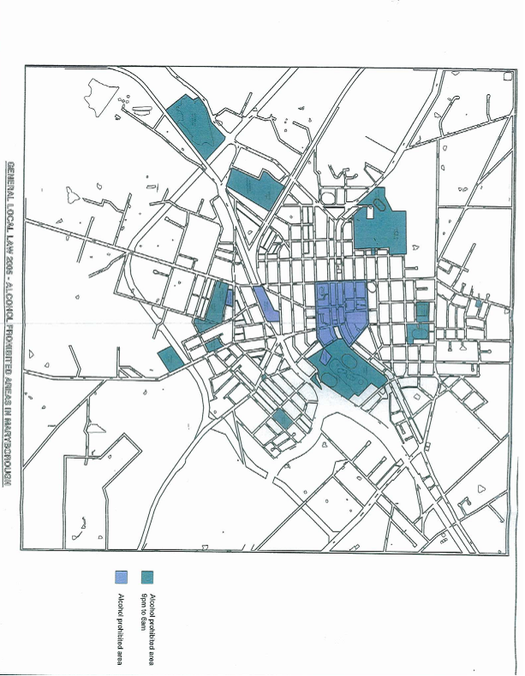**11. ALCOHOL PROHITBITED MA**