Gambling Harm Awareness Week 2025

Community Supporter Toolkit
Contents
Introduction 1
What is Gambling Harm Awareness Week? 2
Why is it important to set limits? 2
Campaign concept and messaging 2
Key messages 2
Quick facts about gambling harm in Victoria 3
Quick guide: How to support Gambling Harm Awareness Week 3
Resources for Gambling Harm Awareness Week 2025 4
Campaign assets 4
Social media 7
Tips for engaging the media 8
Engaging local media 8
Key contacts at the VGCCC 9

Introduction
This supporter toolkit contains all you need to know about how to support Gambling Harm Awareness Week (GHAW) 2025. It is designed for any individual or organisation who would like to support the week and promote the campaign through their own networks.
The toolkit contains promotional materials that include social media assets, web banners, posters, flyers, and other resources to help promote Gambling Harm Awareness Week to your audience.

What is Gambling Harm Awareness Week?
Gambling Harm Awareness Week will run from 27 October to 2 November 2025. This annual event is an opportunity to raise awareness of gambling harm in Victorian communities and encourage discussion about how gambling affects individuals, families, and the community, and what supports are available.
Gambling Harm Awareness Week is supported by the Victorian Government, community organisations and gambling providers.

Why is it important to set limits?
This year’s GHAW theme is about setting limits to reduce the risk of gambling harm. Gambling products can make it easy to get caught up in the moment, especially if someone’s almost winning or chasing losses. The immersive nature of gambling products can make it hard for people to keep track of how long they have been playing and how much they are spending. It’s important to remember that gambling products are designed to keep people playing for longer, which can lead to gambling harm and can impact:
- self-esteem
- relationships
- physical and mental health
- work performance
- social life.

Campaign concept and messaging
The campaign’s message encourages limits on expenditure, frequency of gambling, and the number of gambling products used. This will be communicated as a smart and confident choice that reinforces autonomy and avoids shame.
The campaign is designed to encourage people to adopt these protective behaviours before they gamble. At this time, people are more emotionally equipped to make considered decisions. When people are gambling, they are often emotionally ‘in the moment’, which can drive automatic, immediate decision making and behaviors – rather than making considered choices like setting gambling limits.

Key messages
Set before you bet.
Before you gamble, set a limit and stick to it.

- To protect yourself, set a limit on how much you’ll spend before you gamble.
- Gambling products are designed to keep a person playing for longer so it’s easy to lose track of how much has been spent.
- Setting limits can help reduce the risk of gambling harm.
- There are a range of protective behaviours that can be adopted:
- Gamble no more than 2 per cent of your take home pay.
- Gamble no more than once a week.
- Gamble on no more than 2 different products.

Quick facts about gambling harm in Victoria
- Approximately 440,000 Victorians are either at risk of, or already experience gambling harm.
- Young people are affected by gambling harm at a higher rate than those aged over 65 years, with over a quarter of those aged 18 to 24 years who gamble, experiencing harm.
- Those most likely to experience gambling harm are people who gamble on casino table games (36%), followed by sports (35%), bingo (32%) and poker machines (29%).
(Source: Victorian population gambling and health study 2023)

- Common signs of gambling harm include:
  - stress
  - irritability
  - difficulty sleeping or concentrating
  - drinking or smoking more than usual
  - not spending as much time with family or friends
  - frequently borrowing money
  - intermittent periods of having lots of cash and no cash
  - an intense interest in sporting odds
  - using multiple betting apps.

- Many people experience negative effects from gambling, like stress, regret and guilt, no matter how much or how often they gamble. These effects can start off small and build up, causing stress in their lives.

Quick guide: How to support Gambling Harm Awareness Week
You can support the week by sharing our campaign assets with your networks to reach as many Victorians as possible. By encouraging your contacts to share the campaign, together we can help build awareness of gambling harm. Find the full list of resources and more on the VGCCC website.
  Host your own Gambling Harm Awareness Week event. |   Display a Gambling Harm Awareness Week poster in your workplace or community space.
  Attend a Gambling Harm Awareness Week event. |   Add a Gambling Harm Awareness Week email signature to your emails or display a banner on your website or social media profile.

Follow, share, and comment on Gambling Harm Awareness Week social media using the hashtags #GHAW2025 and #SetBeforeYouBet.

Resources for Gambling Harm Awareness Week 2025
Explore the range of downloadable resources and make a plan to promote, share, and display them in the lead up to, and during, Gambling Harm Awareness Week.

Campaign assets
This is a perfect way to promote the week to internal and external contacts. There are a range of assets for you to use. These include GHAW branded assets announcing the dates, which are available now, as well as GHAW campaign creative which will be available from 13 October.
Assets for download include:
- GHAW logo
- GHAW email signature and header
- GHAW branded static digital banners
- GHAW branded e-newsletter template
- GHAW branded social media tiles
- GHAW branded Microsoft Teams background
- GHAW branded A4 flyer header
- GHAW branded Protective Behaviours Posters A3 and A4 (CALD x 6 languages)
- GHAW branded Protective Behaviours Posters A3 and A4 (English)
- GHAW campaign static and animated digital banners
- GHAW campaign posters A3
- GHAW campaign social media tiles

Posters
Display posters in your workplace or community space to get people thinking and talking about gambling harm.
Preview | Poster title | Description
GHAW campaign poster  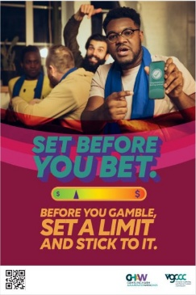  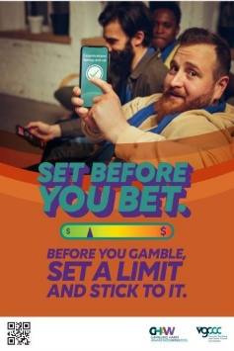 | A3 poster | A3 portrait posters encourage people to set limits and protect themselves from gambling harm.  Display these in your place of work or community space – available from 13 October.
GHAW branded 4 protective behaviours poster  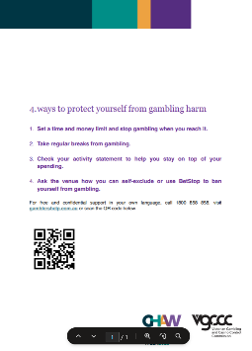 | A4 poster  A3 poster | A3 and A4 portrait posters explain how people can protect themselves from gambling harm with a link to Gambler’s Help  Display these in your place of work or community space (not for industry).
GHAW branded 4 protective behaviours CALD poster  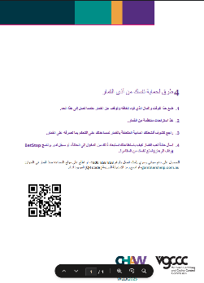 | A4 poster  A3 poster | A3 and A4 CALD portrait  posters explain how people can protect themselves from gambling harm with a link to Gambler’s Help. Available in 6 languages.  Display this poster in your place of work or community space.

Social media
GHAW branded and campaign social media assets will help you promote Gambling Harm Awareness Week on your Facebook, Instagram, and LinkedIn pages. To assist with the promotion please find suggested social media post content:
Post topic | Copy | Asset
Supporting GHAW 2025  (pre-week)  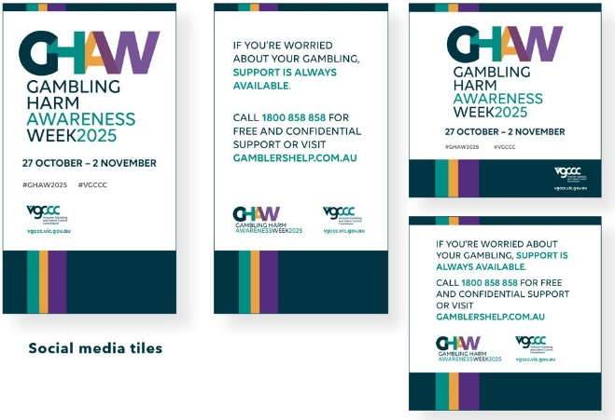  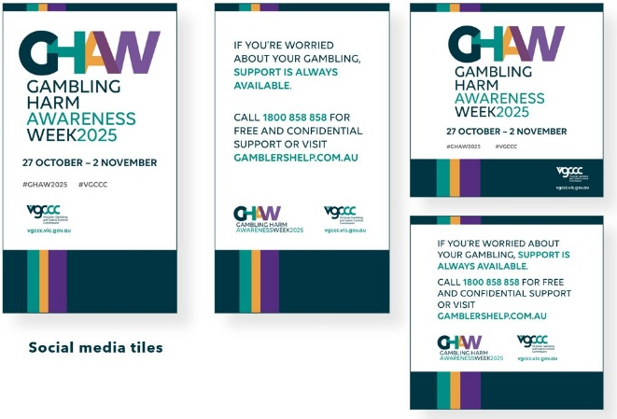 | We’re proud to support Gambling Harm Awareness Week and help Victorians before they gamble to ‘set a limit and stick to it’.  Mark your calendar for 27 October – 2 November to raise awareness and reduce the risk of gambling harm.  Find out more: Gambling Harm Awareness Week | Victorian Gambling and Casino Control Commission  #GamblingHarmAwarenessWeek2025 | Image: Gambling Harm Awareness Week tile  - 4x5 for feed,  - 9x16 for Instagram/Facebook story
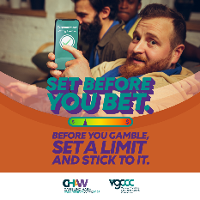  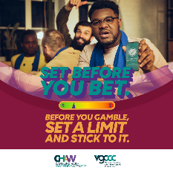  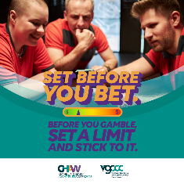  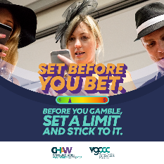  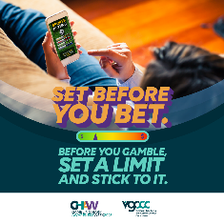  Set before you bet. | Gambling Harm Awareness Week 2025 is a reminder of the importance of setting limits to reduce the risk of gambling harm to yourself and others. Every time before you gamble, set a limit and stick to it. You can also set limits by:  - spending only 2 per cent of your take home pay on gambling  - gambling no more than once a week  - sticking to 2 different types of products.  Small changes can make a big difference.  Find out more: Gambling Harm Awareness Week | Victorian Gambling and Casino Control Commission  #GamblingHarmAwarenessWeek2025  #SetBeforeYouBet | Image: Set before you bet. Static and animated campaign creative for social media feed and stories - available from 13 October.
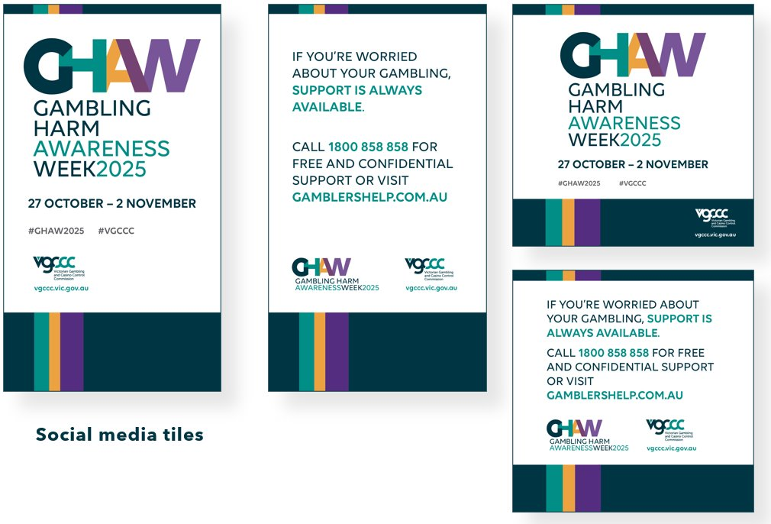  How to get support | If you’re worried about your gambling, support is always available.  Call 1800 858 858 for free and confidential support or visit gamblershelp.com.au.  #GamblingHarmAwarenessWeek2025 | Image: Support is always available  - 4x5 for feed  - 9x16 for story

Social media tips
Social media is a great way to promote your participation and support of Gambling Harm Awareness Week.
Best times to post include:
- Before the week to let your followers know GHAW is coming up.
- Publish your posts during key social viewing times (commute times, lunch and after dinner)
Where possible, link back to the Gambling Harm Awareness Week campaign page on the VGCCC website so people land on the information they need: Gambling Harm Awareness Week | Victorian Gambling and Casino Control Commission (vgccc.vic.gov.au)
Tag us on Instagram and Facebook using @vicgccc and add the hashtags #GamblingHarmAwarenessWeek2025 and #SetBeforeYouBet to your post so we can see it and share it.

Tips for engaging the media
If you want media coverage of your organisation’s event, here are some handy tips.
Local print media includes daily newspapers, online newspapers, and free weekly community papers. You can get your story into the newspaper via a media release, a story or interview that the journalist prepares, a letter to the editor or by contributing to a column.
Local broadcast media includes regional TV and radio (commercial and community) channels.

Engaging local media
Determine a local ‘angle’ – create a ‘hook’ for an interesting story – what’s new/unusual/going to happen, who will be there and why.
Create a photo opportunity – arrange a local community leader/group or someone else who is relevant to the event to do something interesting. Provide media with information to support the photos. Participants do not have to be spokespeople.
Make contact with the local newspaper and/or radio station – consider which presenter or reporter may be most interested in your event. Call them a week or two beforehand to tell them about the event using key points you have prepared earlier to capture their attention.
Write a media alert – this should include the date, time, venue and other details about the event, including the name and phone number of someone they can speak to about it, any photo opportunities and specific areas of interest.
Follow up – after you’ve spoken to the reporter, email your media alert to them and give them a reminder call the day before the event.
Write a media release – this is for you to provide to media on the day of the event. We have prepared key messages that you can tailor to your community and include in the release, which should also include quotes from a spokesperson that a journalist can incorporate into their story (in case they do not interview the spokesperson themselves).
Appoint a spokesperson – the spokesperson will need to know the details of the event, the key messages, some attention-grabbing facts/statistics and a brief anecdote to that personalises the issue. They should practice what they want to say in advance, ensuring they keep information brief and to the point. They should be available to take media calls.

Key contacts at the VGCCC
GHAW campaign support enquiries Media support
T: 1300 599 759 M: 0427 701 037
E: contact@vgccc.vic.gov.au E: media@vgccc.vic.gov.au

Thank you for supporting Gambling Harm Awareness Week 2025.

