Victorian Appendix to the Australian/New Zealand Gaming Machine National Standard
August 2020
Licensing Division

TRIM ID: CD/19/18117
Date: August 2020
Version: 2.0

Contents
V1 Introduction 3
V2 Hardware Requirements 6
V3 Software Requirements 7
V4 Game Design Requirements 10
V5 On-Line Significant Events (Club and Hotel Gaming Venues Only) 11
V6 Responsible Gambling 13
Document information 22

V1 Introduction
V1.1 This Victorian Appendix to the corresponding Australian / New Zealand Gaming Machine National Standard (the National Standard) lists additional or modified requirements to the National Standard that Victoria requires for gaming machines operating in Crown Casino and in Victorian Club and Hotel gaming venues. Where any requirement in this Appendix is in conflict with the National Standard, the requirement as stated in the Appendix shall be enforced.
All technical requirements, if relevant, reference back to their equivalent requirements in the National Standard. At the time of publication of this Appendix, the current National Standard is the National Standard 2016.
When this appendix refers to “this document”, it means the Victorian Appendix and the National Standard together.
See the National Standard “APPENDIX B – LIMITS AND PARAMETERS” for the definition of the Victorian-specific gaming machine parameters.
In this document “Commissioner” means a member of the Victorian Commission for Gambling and Liquor Regulation and the “Commission” means the Victorian Commission for Gambling and Liquor Regulation.
The Commission has the responsibility for administering and enforcing gambling legislation in Victoria. More information can be obtained about the Commission at its website, at www.vcglr.vic.gov.au.
Copying or reproducing this Appendix (or any part of this Appendix) for commercial gain, without prior permission, is prohibited.

Objectives
V1.2 The Commission is looking to set high integrity standards for gaming equipment in Victoria. These standards may well be in excess of those in other jurisdictions. However, the approval of the use of standard devices in other gaming jurisdictions (which have similar standards to Victoria) will not be unreasonably withheld.

Document Scope and Purpose
V1.3 The requirements in this document apply to all gaming machine types and games submitted for approval under section 3.5.4 or 3.5.5 of the Gambling Regulation Act 2003 (the Act).
V1.4 Legislation requires that only approved gaming equipment may be operated in Victoria. This document (together with relevant legislation and regulations) will be used by an Accredited Testing Facility (ATF) to evaluate gaming equipment, prior to the equipment being submitted for approval.
V1.5 Matters arising from the testing of gaming equipment which have not been addressed in this document (e.g. due to omissions or new technology) will be resolved at the sole discretion of the Commission as part of the approval process.

Legislation and Regulations
V1.6 The enabling legislation is the Act and the Casino Control Act 1991 (the CCA) and their associated prevailing regulations. The requirements specified in this document are supplementary to, and do not take the place of, any of the requirements of the legislation.
Under section 3.5.4 of the Act, the Commission may approve or refuse to approve a gaming machine type or a game having regard to:
- Player return, game fairness and security and responsible gambling and
- any standards in force under section 3.5.3; and
- the certificate of a person listed on the Roll being a person referred to in section 3.4.61(1)(c).
The National Standard together with the Victorian Appendix constitute the standard in force (Commission’s Standards) under section 3.5.3 of the Act. The standard is effective 6 months from the date of the making of the standard by the Commission as published in the Victorian Government Gazette. Until the revised version of the Commission’s Standards becomes effective, the current version of the National Standard is acceptable for the purpose of evaluating gaming machine types and games. In this event, the tester’s certificate must report any difference between the revised Commission’s Standards and the current National Standard.
In addition to the Act and Standards, the prevailing Regulations contain provisions across a number of areas of gambling regulation, including operations within gaming venues and casinos, some of which impact on requirements for game and gaming machine design. The prevailing Regulations are available on the Commission website, at www.vcglr.vic.gov.au on the Gambling Legislation and Regulation page.

Other relevant standards
V1.7 The Commission may, from time to time, make other technical standards, which can be found on the Commission website, that are relevant to the design and operation of gaming machines.
V1.8 At the time of publication of this Standard, these standards include technical standards for:
- the monitoring system for clubs and hotels: the Victorian Central Monitoring and Control System Requirements document
- gaming systems (including the monitoring system) operating in the Melbourne Casino: The Technical Requirements for Gaming Machines and Electronic Monitoring Systems in the Melbourne Casino document (TRD) Version 3.0 together with its appendices
- the pre-commitment system: the Victorian Pre-commitment System Requirements document
- pre-commitment player account equipment installed in Victorian Clubs and Hotels or the Melbourne Casino: the Player Account Equipment Technical Requirements document.

Approval Process
V1.9 Contact the staff of the Victorian Commission for Gambling and Liquor Regulation (see “www.vcglr.vic.gov.au”) for information regarding the submission for approval of new gaming machines or gaming machine games (obtaining an Application for Approval form for a new gaming machine or game).

Provision of Information
V1.10 The Commission may require information on currently approved gaming equipment in operation. Therefore, venue operators and manufacturers must maintain and retain all records pertaining to the design, manufacture and test of the equipment.

Equipment Operation
V1.11 Gaming equipment which does not fully comply with all requirements specified in this document may be considered for approval provided the gaming equipment operates in a manner that is suitable in respect of:
- player return;
- game fairness and security; and
- responsible gambling

V2 Hardware Requirements

Power Supply
V2.1 Where a gaming machine cabinet contains more than one power switch, each switch must clearly identify which unit it applies to.

Hoppers
V2.2 The hoppers installed in gaming machines operating in Victorian Club and Hotel gaming venues shall have a hopper cover.
See also V3.5 and V3.6 for relevant software requirements.

V3 Software Requirements

Software Functions Provided
V3.1 All implemented functions must operate according to the intended design. All messages displayed must be true and accurate and the software must be free of unintended side effects.

System Security

De-activation when a Logic Area has Been Accessed
V3.2 When a gaming device determines that a restricted area has been accessed, the device is to deactivate itself until appropriate investigations are conducted, at which time the device may only be re-activated by a method approved by the Commission (see V5.4 Logic Area Access, Power-Off Logic Area Access).

Software Signature Checking
V3.3 This paragraph deleted.
V3.4 All memory crucial to the operation of the gaming machine (game application software, communications, operating systems, etc.) must be included in the software signature check. Non-critical memory (such as graphics) may be excluded, provided it is logically separated.

Coin Diverter
V3.5 The Commission will not approve any gaming machine without a hopper if the only method of routing coins to the drop box is “software diversion”.

Coin Hopper
V3.6 In addition to accounting procedures used by software to determine the level of a hopper, if a hopper full sensor is provided, software must also interpret that sensor output to determine if a hopper is full.

Credit Redemption

Cash Out While De-activated
V3.7 The Commission requires that players who have a non-zero credit balance when de-activation occurs should be given the option to “cash-out” their balance. In the situation where the deactivation may last for a lengthy period of time, if there is enough of the system available at subsidiary points to enable a safe and accurate pay, this may be performed.

Cash Clearance Procedures
V3.8 The gaming machine must display the appropriate meter information for cash clearance. The accounting information must be available both for the entire period of operation of the gaming machine (since the last Memory Reset) and since the last Cash (Coin or Note) Clearance.

Stand-Alone Gaming Machines not Permitted
V3.9 Installed gaming machines must at all times, while in operational mode (where valid game play is possible), be in on-line communication with the CMCS.

Substantial Wins
See also National Standard Section 6.106
V3.10 Substantial Wins must cause the gaming machine to enter a lock-up mode until external intervention, i.e. use of attendant key and, after system software verification by the central monitoring and control system, “game enabled” command.

Credit Redemption
See also National Standard Section 6.50
V3.11 Available credits may be collected from the gaming machine by the patron pressing the “COLLECT” button at any time other than:
- during a play;
- while in Audit mode;
- while any door open condition exists;
- while in Test mode;
- while the player’s Credit Meter or Total Wins Meter is incrementing;
- while the game is in Player Information Display (PID) mode, or
- while the EGM has lost the communication to the host and is not in a logic door access detection state
- while any fault condition exists
(Notwithstanding V3.11(h), at the manufacturer’s discretion, credits may be collected from the gaming machine if the only existing fault condition(s) is(are):-
i) ticket printer failure/paper error,
ii) progressive controller error, or
iii) banknote acceptor full.)

Last Play Information Required
Refer to National Standard Section 7.15.
V3.12 After subsection (k) of the National Standard section 7.15, insert:
“l). the total number of external bonus/jackpot credits paid directly to the credit meter in dollars and cents as a result of the last play and obvious to the player (e.g. where the credit meter has been incremented).”

Non-Fault Gaming Machine Events (Where Substantial Win occurs)
See also National Standard Section 6.77.
V3.13 Under “Cleared By” Column change “Cleared by an attendant” to “Cleared by an attendant only after a system software verification by the central monitoring and control system followed by a ‘game enabled’ command”.

V4 Game Design Requirements
V4.1 When transferring progressive prizes to the player’s credit meter, any residual amount less than the base credit value not transferred to the player’s credit meter must be incorporated into the next progressive prize.

Large Win Prize Truncation
V4.2 In no circumstances should a large win have its prize amount truncated or limited due to constraints of a game rule, gaming machine’s memory storage, screen display, artwork or any other such reason. If there are possible prizes that may exceed a program limit or constraint, the prize table and/or maximum wagers for a game must be structured such that the highest win cannot exceed this limit. Permitted exceptions are re-spin/free games which provide a possible infinite prize but where the probability of this occurrence is infinitesimal.

Random Prize
See also National Standard Section 5.31
V4.3 A game may offer random prizes (fixed value prizes that are awarded at random following a spin, that are not symbol-driven and not part of a stand-alone progressive jackpot or a linked jackpot arrangement) provided that:
- all plays (regardless of number of lines or credits staked) have an opportunity to win the prize; and
- the chance of winning the prize is proportional to the credits bet.

Multi-line Games – Display of Lines Selected
See also National Standard Section 4.4 and 4.5
V4.4 In regard to multi-line games, each individual possible line which is activated (as a lit selected line/pattern/reel), by betting additional or current credits, must be clearly indicated by the gaming machine, so that the player is in no doubt as to which lines are being bet on.

V5 On-Line Significant Events (Club and Hotel Gaming Venues Only)
V5.1 This section is a summary of each of the Significant Events that are required to be reported or actioned, and an indication of what type of significant event this is (relative to requirements for de-activation and reactivation).

Time Criteria for Reporting Events
V5.2 The following significant events are to be detected and notified within ten seconds of occurrence or as soon as possible after restoration of communications.
V5.3 Power Fail:
- If the power fails the equipment is, by default, deactivated. When power is returned, the equipment must check to see if the logic door has been opened and if so, remain de-activated until manual re-activation and only after a signature check is completed and verified by the CMCS.
- If the logic door has not been opened, the Operator can either have the equipment automatically re-activate or require manual re-activation but only after a signature check is completed and verified by the CMCS.

V5.4 Logic Area Access, Power-Off Logic Area Access:
The gaming machine must detect the opening of the logic cabinet door even if the power is off when it occurs and even if the central monitoring system is not operating. The gaming machine must be manually re-activated only after a signature check is completed and verified by the CMCS. Re-activation must involve the participation of the CMCS with a manual command issued by a system operator in order to re-enable the gaming machine.
V5.5 Logic Area Sealed:
A sensor has registered that a logic door has gone from “open” to “closed” and the EGM has completed the procedure as given in V5.4.
V5.6 Communications Failure:
Failure of communication link between a gaming machine and its next point in the monitoring system.
Failure is defined to be a period of no communications for 10 seconds or longer. When communications are restored, the gaming machine must check to see if the logic door has been opened and if so, remain de-activated until manual reactivation and only after a signature check is completed and verified by the CMCS. If the logic door has not been opened, the venue operator can either have the equipment automatically re-activate or require manual re-activation only after a signature check is completed and verified by the CMCS.
V5.7 Cash Out:
Cash outs greater than or equal to Commission specified limit: The default value for this limit is to be $2,000. Note that wins of $2,000 or more require personal identification before payment of winnings (which must be by cheque in the name of the player or by EFTPOS in accordance with conditions specified in the Act) can be made.
V5.8 Jackpot:
Winning of a jackpot prize: Although the Regulations do not indicate to de-activate upon any jackpot win, the winning of a jackpot prize together with any game wins that is greater than the large win limit will mean the gaming machine must de-activate itself (or be de-activated by the host, if the host is determining the jackpot). The default value for this limit is $10,000. The gaming machine may be re-activated only after appropriate Audit procedures have been completed and after a gaming machine signature check is completed and verified by the CMCS. Note that there is no mandatory requirement to log a jackpot win significant event if the prize amount is less than the Commission specified default limit of $10,000.
V5.9 Large Wins:
Winning of a prize greater than or equal to the Commission specified limit: This limit may be different from the previous limit. The default value for this limit is to be $10,000. The gaming machine may be re-activated after appropriate Audit procedures have been completed but only after a gaming machine signature check is completed and verified by the CMCS.
Note that in the de-activated state the gaming machine shall not continue game play nor pay the credit balance to the player via a collect, cancel credit, ticket print or other such means until a gaming attendant has cleared the win at the gaming machine.
V5.10 Game Play Activated:
Activation including re-activation of game play: Activation and de-activation at normal commencement and conclusion of business requires the generation of significant events (by the CMCS or by the gaming machine) so that the system can identify that the gaming machine status has changed. This does not mean that the monitoring system must send a separate message to the central point of the system for each one of these events that happens. It is permitted for the system to send a message giving an indication of change of status of several gaming machines as long as the status change events all occurred within 10 seconds of each other.
V5.11 Game Play De-Activated:
De-activation of Game play: If a significant event has not already been logged (by the CMCS or the gaming machine) when de-activation occurs, the gaming machine must ensure that one is sent to the CMCS as soon as possible. If the gaming machine receives instruction to de-activate by any other part of the monitoring system, it must de-activate immediately, and must not re-activate until instructed to do so by the CMCS.
V5.12 Mechanical Meters De-activated:
If there is non-secure wiring between the mechanical meters and the logic board, the gaming machine must be able to detect when its mechanical meters are disconnected and generate this significant event.

V6 Responsible Gambling
The Act provides for the Commission to approve or refuse to approve a gaming machine type or a game having regard to responsible gambling, the Commission’s standards in force under section 3.5.3 and the certificate of a tester listed on the Roll. In addition the current criteria of player return, game fairness and security still apply. The following are requirements that are supplementary to and do not take the place of any of the requirements of the Act.

Game Artwork / name and Screen Display
V6.1 Artwork must not:
- be factually incorrect
- be misleading or deceptive
- suggest that playing a gaming machine is likely to improve a person's social status
- suggest that playing a gaming machine is likely to make a person more attractive to others
- suggest that playing a gaming machine is likely to result in a person's financial betterment
- describe money spent in playing a gaming machine as an investment
- suggest that a player's skill can influence the outcome of a game that is purely a game of chance; or
- suggest that a person's chances of winning a prize are influenced by the length of time for which a person plays a game.

V6.2 Game name must not:
- suggest that playing a gaming machine is likely to improve a person's social status
- suggest that playing a gaming machine is likely to make a person more attractive to others
- suggest that playing a gaming machine is likely to result in a person's financial betterment
- be misleading or deceptive
- describe money spent in playing a gaming machine as an investment
- suggest that a player's skill can influence the outcome of a game that is purely a game of chance; or
- suggest that a person's chances of winning a prize are influenced by the length of time for which a person plays a game.

V6.3 Games can offer what might otherwise appear to be an illusion of control if it is clear to players that no action of the player can influence the outcome of the game or any element of the game. Advice to players may be provided in the static artwork or via game play information which makes clear and in readily available and visible format that no action of the player can influence the outcome of the game.

Spin rate
V6.4 For a game approved by the Commission after 1 January 2003, unless the game is to be operated in the approved “specified area” the spin rate or interval between spins on the gaming machine must not be less than 2.14 seconds per play.

Maximum Bet Limit
V6.5 For a game approved by the Commission after 1 January 2003, unless the game is to be operated in the approved “specified area” the games on gaming machines must not allow a bet above the maximum amount as determined from time to time by the Minister in accordance with the Act.

Display of time
V6.6 Current gambling regulations, available on the Commission’s website at www.vcglr.vic.gov.au, specify the requirements for electronic gaming machines to display the time of day. The regulations include, but are not limited to, the following requirements:
- The time of day must be displayed by a time display which may be located on the video screen (see Diagrams 1 and 2 at the end of this document) of the gaming machine
- The time of day displayed must be clearly visible to a person playing a game on the gaming machine
- The time of day displayed must be to an accuracy of within 5 minutes and must indicate whether the hour is before or after noon
- The time of day must be displayed continuously while the machine is operating and available for use for gaming, and
- The time of day displayed must not obscure any other information relevant to gaming on gaming machines.
The current regulations provide detailed specifications on the location of time of day on a gaming machine.

Game Play
V6.7 A game must follow a constant set of rules and must at no time deviate from those rules. A rule change constitutes a different game, although variations to the maximum number of credits bet per game (and/or lines per game) are permitted. This requirement does not preclude implementations of games with multiple parts or features and/or gamble provided that the rules are clear to the player.

Multiple Games – Selection of Game for Play
V6.8 The methodology employed by a patron to select and discard a particular game for play on a multi-game gaming machine must be clearly explained to the patron on the gaming machine, and be easily followed.
V6.9 The gaming machine must clearly inform the patron of all games available at that time and offer them for selection.
V6.10 The patron must at all times be made aware of which game has been selected for play and is being played, as applicable.

Autoplay
V6.11 For a game approved by the Commission after 1 January 2003, unless the game is to be operated in the approved “specified area” each spin or wagering of credits can only be initiated by a distinct and separate activation of the machine by the player.

Note Acceptor
V6.12 For a game approved by the Commission after 1 January 2003, unless the game is to be operated in the approved “specified area” the game must not be played with a gaming machine that accepts banknotes with a denomination greater than $50.

Maximum Starting Credits
V6.13 This section applies to gaming machines other than those located in the Melbourne Casino. When accumulated credits reach a value of $1,000, the gaming machine must not accept any further cash input (coin, note or electronic transfers other than prize payments). Cases where the insertion of a coin or note takes place when the accumulated credit is below $1,000 and the insertion of the coin or note causes the credits to exceed $1,000 are not acceptable i.e. if the accumulated credits are $951, then the bank note acceptor must not accept a note to the value of $50, however it may accept lower note configurations, provided that the accumulated credits will not exceed $1,000.
Note that electronic transfers of EGM or jackpot prizes is permitted, even if the credits displayed exceed $1000.

Electronic Information for Players
V6.14 The requirements for the electronic display of information by gaming machines are laid down in the prevailing Regulations. This includes the display of electronic game information, electronic player information and the time of day. At the time of issue of this version of the Victorian Appendix, the requirements for electronic game information as stated in the Regulations are:
Obligation for display of electronic game information and electronic player information:
Gaming machine must generate and display electronic information
(1) A venue operator or casino operator who knows, or who could reasonably be expected to know, that a gaming machine is not able to display electronic game information at the instruction of a player must not permit gaming on the gaming machine.
(2) A venue operator or casino operator who knows, or who could reasonably be expected to know, that a gaming machine is not able to display electronic player information in accordance with subregulation (3) must not permit gaming on that gaming machine.
(3) A gaming machine is able to display electronic player information in accordance with this subregulation if a player of the gaming machine is able to—
(a) instruct the machine to begin generating electronic player information; and
(b) instruct the machine to display the electronic player information that relates to the period beginning with the instruction referred to in paragraph (a) and ending at the earlier of—
(i) the time when the player gives the instruction referred to in this paragraph; or
(ii) the end of a period of 60 seconds during which no games are played on the machine.

What is electronic game information?
electronic game information means the following information in relation to a game that may be played on a gaming machine—
- the return to player of that game;
- the average number of individual games played for each win, based on one line being played per game, which may be described as "theoretical number of individual games played per win";
- the odds of achieving the 5 most valuable individual winning combinations;
- the odds of achieving the 5 least valuable individual winning combinations;
- the maximum and minimum bet options available;
- if the gaming machine is part of a linked jackpot arrangement—
(i) a statement that the gaming machine is part of a linked jackpot arrangement; and
(ii) the sum of the return to player contributed by the game and the return to player contributed to the linked jackpot arrangement, which may be described as "total return"; and
(iii) the return to player of the game contributed by the linked jackpot arrangement;

What is electronic player information?
electronic player information means the following information in relation to a continuous period of gaming on a gaming machine by an individual player—
- the amount of money the player has put into the gaming machine during the period, which may be described as "cash in";
- the amount of money wagered by the player on the gaming machine during the period, which may be described as "credits played";
- the amount of money won by the player on the gaming machine during the period, which may be described as "credits won";
- the difference between the credits won and the credits played during the period, which may be described as "session win or loss";
- the amount of money paid out by the machine during the period which may be described as "cash out";
- the amount of money that is currently available for the player to wager on the machine, which may be described as "credits available";
- the time at which the period started;
- the current time of day;
- the length of the period;
- if amounts won in a jackpot are not included on the credit meter of the gaming machine, a statement that the information displayed does not include amounts won in a jackpot during the continuous period of gaming;

Interpretation and Examples
V6.15 The following interpretations are to be used in conjunction with the requirements for electronic game information:
- if a game operates with more than one Return to Player or with a range of RTP, the range of RTPs must be displayed. If the game is part of a linked jackpot arrangement, the total theoretical RTP of this game and the jackpot contribution rate must be displayed.
- where the average number of individual games played per any win, based on one line being played per game, is not possible, the average number of individual games played per any win, can be based on the minimum bet per game play.
- In relation to the chances or odds of achieving the top 5 and bottom 5 winning combinations, where more than one symbol pays the same amount, either the order by chance, hierarchy or alphabetical value can be used for display. For example, if five “Tens” and five “Queens” pay the same amount the “Queens” combination may be displayed first. Similarly if five “Apples” and five “Oranges” pay the same amount the “Apples” may be displayed first.
- If an automatic timeout period is implemented for displaying the electronic game information, the timeout period must not be less than 30 seconds.

For example the content and format of the EGI, see screen below:
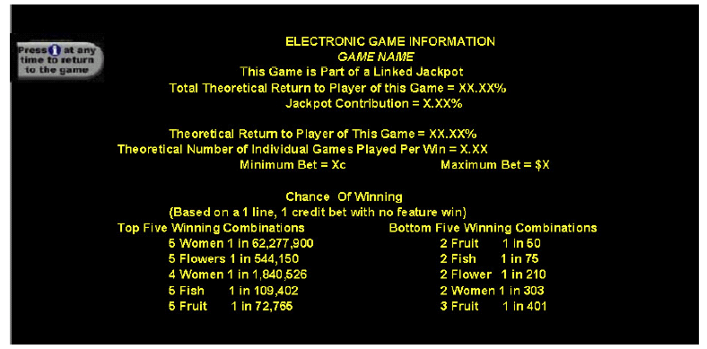
The above screen shows the top 5 winning combinations displayed by value prize from highest to lowest and the bottom 5 from lowest to highest.
V6.16 the following are examples of how electronic player information may be displayed.
Example 1
The following is an example of electronic player information on a system where all jackpot win amounts are included on the credit meter:
Cash In | $100.00
Credits played | $245.50
Credits Won | $239.70
Session Win or (Loss) | ($5.80)
Cash out | $0.00
Credits available | $94.20
Time commenced | 8:48 pm
Current time | 10:52 pm
Total time played | 2 hours 4 minutes
Example 2
The following is an example of electronic player information on a system where some jackpot win amounts are not included on the credit meter:
Cash In | $100.00
Credits played | $245.50
Credits Won | $239.70*
Session Win or (Loss) | ($5.80)*
Cash out | $0.00
Credits available | $94.20*
Time commenced | 8:48 pm
Current time | 10:52 pm
Total time played | 2 hours 4 minutes
*These totals exclude jackpot amounts not included on the credit meter.

V6.17 The following interpretations are to be used in conjunction with electronic player information requirements:
- if an automatic timeout period is implemented for displaying the electronic player information, the timeout period must not be less than 60 seconds.

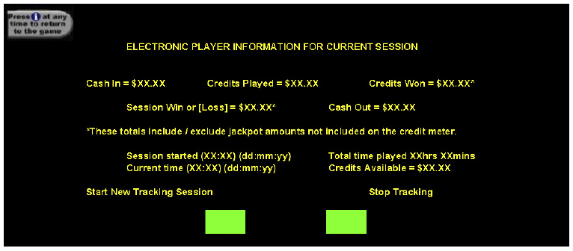
See below for an example of acceptable content and format for the electronic player information screen.

Diagram 1
Gaming machine with top box
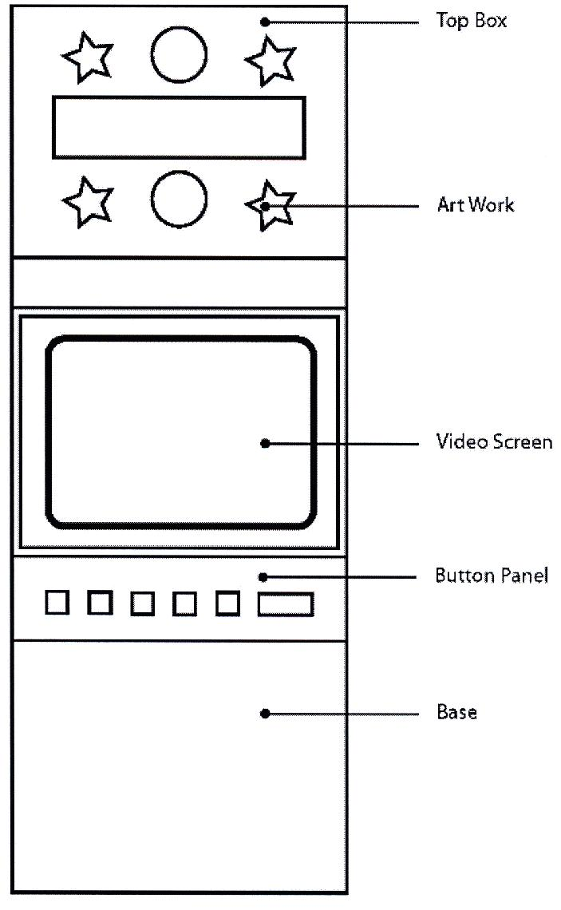

Diagram 2
Gaming machine without top box
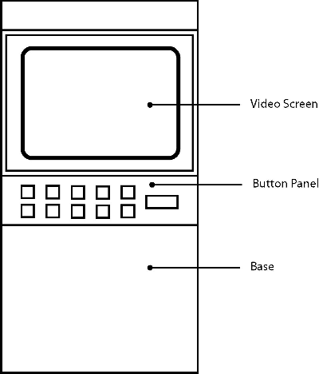

Document information

Document details
Criteria | Details
TRIM ID: | CD/19/18117
Document title: | Victorian Appendix to the Australian/New Zealand Gaming Machine National Standard – August 2020
Document owner: | Manager, Licence Management & Audit

Version control
Version | Date | Description | Author
V1.0 | 06/03/17 | Publicly released version | Steve Thurston
V1.1 | 30/03/17 | Typographical corrections made:  - V1.3 “gaming machines” replaced with “gaming machine”  - V1.3 “Gambling Regulation Act 2003” spelt out and abbreviated.  - V1.6 “Gambling Regulation Act 2003” replaced with “the Act”  - V3.3 deleted (identical to V3.4 except V3.4 has “…provided it is logically separated”)  - V3.11(i) and (j) deleted (identical to V3.11(f) and (g) respectively.  - V5.10 “an indication” instead of “indication”.  - V6.5 removed unnecessary italics. | Steve Thurston
V1.2 | 22/03/18 | Introduction of second tranche of changes for Messaging from a Gaming Machine (V6.18) and restrictions on display of past gaming results (V6.19)  (CHANGES NOT APPROVED) | Jason Cremona
V1.3 | 25/10/2019 | Changes to return to player references, introduction of corrective statement to PID, and alignment of V5.7 with legislative change to cash out limit  (CHANGES NOT APPROVED for changes to return to player references) | Jason Cremona
V1.4 | 28/08/2020 | Section V2.1, V2.2, V2.3 in relation to hard meters are removed. As a result, V2.4 & V2.5 changed to V2.1 & V2.2.  Include changes to V5.7 as approved by the Minister when assessing version 1.3.  If approved, V2.0 to be released publicly. | Jason Cremona

Audience
The audience for this document includes game and gaming machine suppliers, testers and venue operators to ensure that games or machines submitted for approval in Victoria meet all legislative and regulatory obligations specific to Victoria.

Reference material

Bibliography | Author | TRIM ID/Location
Australian/New Zealand Gaming Machine National Standard 2016 | ANZ gaming machine working party | CD/19/18117

Terms | Description
CCA | Casino Control Act 1991
CMCS | Central Monitoring and Control System
VCGLR | Victorian Commission for Gambling and Liquor Regulation

A “specified area” is an area in which the provisions of sections 62AB,62AC and 81AB of the Casino Control Act and sections 3.5.29 and 3.5.30 of the Act apply.
A “specified area” is an area in which the provisions of sections 62AB,62AC and 81AB of the Casino Control Act and sections 3.5.29 and 3.5.30 of the Act apply.
A “specified area” is an area in which the provisions of sections 62AB,62AC and 81AB of the CCA and sections 3.5.29 and 3.5.30 of the Act apply
A “specified area” is an area in which the provisions of sections 62AB,62AC and 81AB of the CCA and sections 3.5.29 and 3.5.30 of the Act apply

